2. Literature Review

Introduction
This chapter presents a comprehensive review of existing literature relevant to the following areas:
- The incident at the Windscale nuclear Power Plant (1957) The 1986 Incident at the Chernobyl Nuclear Power Plant
- Radionuclide Dispersal across Europe and mainly the United Kingdom as this is my area of focus.
- Previous Monitoring Systems
- Introducing IoT Networks and Sensing technology
- Employing IoT Based Wireless Senor Network for Radionuclide monitoring
2.1 Theoretical Background

2.1.1: Nuclear Accidents
Overview:
Since the advent of nuclear technology in the mid-20th century, humanity has harnessed the atom for energy, medicine, industry, and defence. However, the enormous power contained within nuclear materials has also led to a large range of incidents—accidents, mishaps, and unintended releases of radioactivity—that have occurred worldwide.

These nuclear incidents vary widely in scale and impact, from localized contamination involving lost or mishandled radioactive sources, to catastrophic reactor meltdowns that reshaped energy policies and public perceptions.

Nuclear incidents can be broadly categorized into civilian nuclear reactor accidents, military nuclear weapon mishaps, criticality accidents in research or fuel processing facilities, radiological accidents involving orphan sources, transport-related incidents, and events related to nuclear-powered satellites and naval vessels. The severity ranges from minor, quickly contained events causing no significant harm, to major disasters such as the Chernobyl and Fukushima meltdowns, which resulted in widespread environmental contamination, health consequences, and long-term socio-economic effects.

While nuclear technology has advanced safety systems and regulatory oversight, the history of nuclear incidents highlights the critical importance of stringent safety culture, international cooperation, and transparent reporting. The cumulative lessons from these events have driven improvements in reactor design, emergency preparedness, and radiological protection worldwide.

Despite the risks, nuclear energy remains a significant part of the global energy mix, underscoring the ongoing challenge of managing nuclear technology responsibly. Over the next couple of sections, I shall explore two major nuclear incidents that have affected the United Kingdom.

2.1.1.1: Windscale (United Kingdom 1957)
The UK’s worst nuclear accident occurred on 10 October 1957 at the Windscale nuclear facility in Sellafield. The first of two atomic piles—constructed in 1950 and 1951 as part of Britain’s nuclear weapons programme—caught fire, releasing radioactive material into the surrounding environment.

These 120-metre-high reactors were graphite-moderated and air-cooled, containing horizontal channels through which uranium cartridges were inserted and irradiated to produce plutonium. Following the accident, Pile 1 was permanently sealed, and Pile 2 was shut down soon afterwards [].

2.1.1.1.# Background History of Windscale
Windscale is a historical name for the Nuclear Power Plant now called Sellafield[], which is in Seascale, Cumbria on the Northwest coast of mainland England.

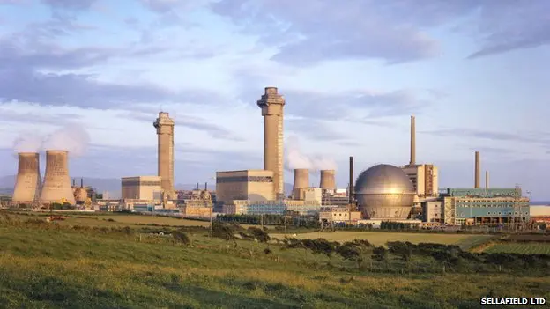
Figure 1: Windscale Nuclear Power Plant (Seascale)[]

The Windscale site, later chosen for the development of the United Kingdom’s nuclear facilities, had previously served as an ordnance factory during the Second World War, where it was involved in the production of trinitrotoluene (TNT)[]. Following the end of the war—precipitated by the deployment of nuclear weapons over Hiroshima and Nagasaki—the strategic priorities of the UK Government shifted significantly.

By September 1947, the Government had designated Windscale’s primary function as the production of plutonium[] for the British nuclear weapons programme. This decision was driven by the absence of technical assistance from the United States, as well as increasing geopolitical pressure following the Soviet Union’s successful detonation of its first nuclear device. In response to these developments, Britain sought to establish itself as a nuclear power. This effort culminated in 1952 with the nation’s first successful nuclear weapons test, conducted during Operation Hurricane in Australia.

Windscale had 2 reactors called Piles, Pile No.1 went operational in October of 1950 followed by Pile No.2 in June 1951, this was just 5 years after construction began back in 1947, the speed in which the plant was built, was remarkable considering the construction speed of nuclear power plants of today (I worked at Hinkley Point C during its early construction stage from 2017-2021, and even today “December 2025”, its only just over half way finished). Each pile at Windscale contained 180t (Tonnes) of Uranium fuel encased in aluminium-clad elements which were placed on 3440 horizontal channels within the 2000t graphite moderator[].

To understand what a Graphite Moderator is and how it works in relation to nuclear reactors, we first need to understand Uranium 235 (²³⁵U) the fuel used in Nuclear Reactors, how its manufactured and how it behaves when in the reactor.

The Uranium Mining Process:
Uranium is a naturally occurring element/isotope that can be found Iin the earth in low concentrations. The concentration is around 2.7 parts per million. Uranium can be found in major deposits in Canada[], Australia[], Africa[], Russia[] and USA[]. Mining of Uranium will be determined on how the Uranium is deposited, it can be mined via surface or open pit these are where deposits are shallow and no more than 100m below the surface, where deposits are more than 100m below the surface underground mining will take place with careful infrastructure of ventilation to protect the miners from radiation exposure.

The Uranium Milling Process:
The milling process is used to extract uranium from the ore (see Image) extracted from the mine. This stage is typically carried out near the mining operation and results in the production of a uranium concentrate commonly known as yellowcake. This concentrate, which contains approximately 60% uranium, is significantly easier and more cost-effective to transport than raw ore. The milling process also generates a large volume of waste material, known as tailings, which accounts for roughly 99% of the original ore’s mass.

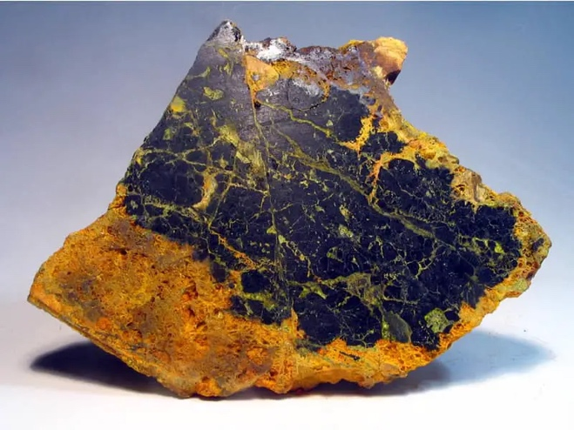
Figure 2: Uranium Ore[]

The Uranium Enrichment Process
Once yellowcake uranium (Triuranium Octoxide, U₃O₈) (See Image) has been produced, it must undergo further refinement and processing before it can be used as nuclear reactor fuel. The yellowcake is first converted through a series of chemical reactions into uranium hexafluoride (UF₆), a compound suitable for isotopic enrichment.

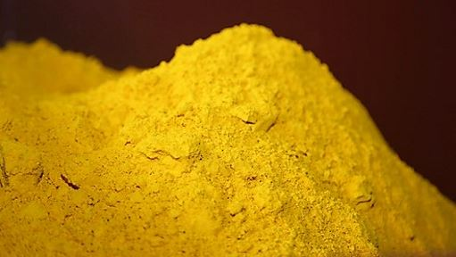
Figure 3: Yellowcake Uranium[]

Natural uranium consists primarily of two isotopes: uranium-235 (²³⁵U), which makes up approximately 0.7% of the total, and uranium-238 (²³⁸U), which accounts for the remaining 99.3%. Only ²³⁵U can sustain nuclear fission, the fundamental process by which energy is generated within a nuclear reactor. Consequently, uranium-235 is the critical isotope targeted during the enrichment stage.

Enrichment is typically achieved using one of two industrial processes:
Gas centrifuge enrichment
Gaseous diffusion

Both methods rely on uranium hexafluoride in gaseous form as the feed material. During enrichment, the proportion of ²³⁵U is increased from its natural level of 0.7% to typically between 2% and 4%, suitable for use in most commercial light-water reactors. Following enrichment, the UF₆ is converted into a fine black powder of enriched uranium dioxide (UO₂), which is then ready for the pellet-fabrication stage of fuel manufacturing.

Uranium Compacting & Fuel Manufacturing
The enriched Uranium Dioxide (UO₂) it put through a pellet moulding machine, there are 2 designs that manufacturers choose, Solid or Annular (See Images below)

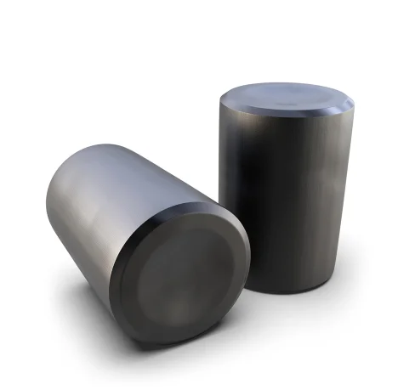 | 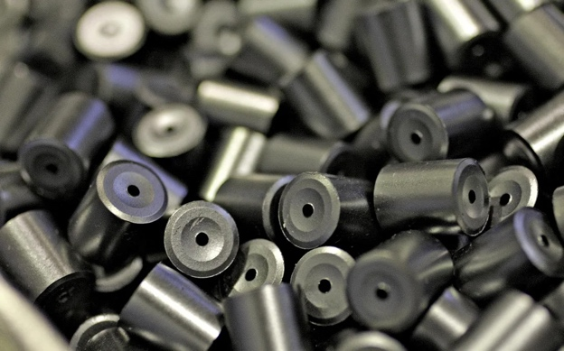
Figure 4: Uranium Solid Fuel Pellet[] | Figure 5: Uranium Annular Fuel Pellet[]

The solid design is as its named a solid pellet of Uranium Fuel the other is Annular, which means that it has a hole down through the centre of the pellet, A Bergeron et al (2013)[] abstract statement explains why they have a hold, this is to allow coolant to flow through the pellet and around the outside when inside the reactor.

The pellets are put through a forming machine similar to the tablet/sweet machines that make our medicine tablets from powder where the Uranium Dioxide is squeezed in moulds with the pressure of approx. 20 tonnes, and produces ceramic pellets (Green Pellets / Pre Baking) (See Image below) each tablet before baking has the following dimensions:
Diameter: 8.6mm – 8.8mm
Height: 10-12mm
They are made slightly larger because they shrink during the baking process.

These ceramic pellets need to go through a hardening process (Sintered Pellets) (See Image Below) where they are baked in a furnace for a period of 24 hours. This removes any further moisture from the pellets causing them to shrink slightly to its final size with the following dimensions:
Diameter: 8.19mm – 8.26mm
Height: 9.5mm – 10.5mm

Add Fuel Image Pre-Baking[] | Add Fuel Image Post-Baking[]

Each pellet has a slightly dished or chamfered end, this help reduce stress and cracking during the baking process. Fuel pellets when made and before baking are bigger, weaker and porous, then when baked are dense, precise ceramic cylinders.

“Every Atom of ²³⁵U is like a bullet, travelling at nearly the speed of light, penetrating everything, wood, metal, flesh. Every gram (1g) of ²³⁵U holds over a billion, trillion bullets, (atoms) that’s in just 1g. most of these bullets will not stop firing for hundreds of years, some for over 50,000 years.”[].

Nuclear Fission
When uranium-235 (²³⁵U) undergoes fission, a neutron is expelled from the nucleus with considerable energy, causing the remaining fission fragment to recoil. The emitted neutron typically possesses a kinetic energy of approximately 1–2 MeV, which corresponds to a velocity of between 10,000-20,000km/s[].

At these velocities, the neutron is classified as a fast neutron. Fast neutrons have a relatively low probability of inducing further fission in another ²³⁵U nucleus because their high speed significantly reduces the likelihood of interaction. Consequently, without intervention, most fast neutrons will escape without contributing to a sustained chain reaction.

To address this, nuclear reactors employ moderators—materials introduced specifically to slow fast neutrons to thermal energies where the probability of fission is much higher. Common moderating materials include water (light or heavy water) and graphite, both of which are highly effective at reducing neutron speed through repeated elastic collisions.

Neutron Flux & moderation using Graphite

Neutron Flux:
Neutron flux can be understood as the number of neutrons passing through a given area per unit time, analogous to the flow of vehicles along a motorway. In this analogy, a speed checkpoint represents the moderator, which slows the vehicles as they pass through. Similarly, in a nuclear reactor, materials such as graphite or water act as moderators, reducing the speed of fast neutrons and thereby increasing the likelihood of interactions necessary to sustain a controlled nuclear chain reaction.

Neutron Moderation using Graphite
As previously stated the neutrons from the Uranium-235 (²³⁵U) are travelling at such a high rate of speed they are very unlikely to hit another uranium atom, Moderators are introduced to slow down the speed of the neutron.

After neutrons are slowed by the moderator, neutrons in a reactor primarily follow one of two paths. They may be absorbed by the control rods (See Image: ADD CONTROL ROD IMAGE), which are made of materials such as boron or cadmium that have a high neutron-absorption cross-section. This absorption regulates the number of neutrons available and therefore controls the rate of the chain reaction.

Add Image of Reactor Safety Control Rods[]

Alternatively, moderated/thermalised[] (thermal) neutrons may pass through the graphite or water moderator and go on to collide with another uranium-235 (²³⁵U) nucleus. At thermal energies, the probability of inducing fission is greatly increased, enabling the sustained chain reaction required for reactor operation.

What is Graphite:
Graphite is a crystalline form of carbon arranged in hexagonal layers (See Image), and its purity is critically important, particularly for applications in nuclear reactors. High-purity nuclear graphite is produced through extensive purification processes designed to remove trace impurities such as iron, silicon, and aluminium, which can adversely affect reactor performance and neutron behaviour.

Add image of Graphite Lattice Structure[].

One purification method involves acid leaching, which removes metallic and mineral contaminants. Another widely used technique is high-temperature thermal purification, in which the graphite is heated to temperatures exceeding 2,500 °C. At these temperatures, volatile impurities are vaporised without damaging the graphite’s carbon lattice structure.

Following purification, the graphite powder undergoes a series of manufacturing steps, including crushing, milling, sieving, and the addition of a pitch binder through kneading and mixing. The material is then subjected to further milling before being placed into moulds and shaped according to its intended application. The moulded graphite components are subsequently baked to set their structure and achieve the required mechanical properties. Finally, the finished products undergo rigorous inspection and quality-control procedures to ensure compliance with nuclear-grade standards[]. (See image of Nuclear Reactor Graphite Block)

Add Image of Nuclear Reactor Graphite Block[]

Back to the Nuclear Fission process:
Once a neutron has been slowed by the moderator (Graphite/Water), it becomes much more likely to interact with another uranium-235 (²³⁵U) nucleus. Upon absorbing the neutron, the ²³⁵U nucleus is transformed into uranium-236 (²³⁶U), an unstable isotope. This instability causes the nucleus to undergo fission, splitting into two lighter fission products—commonly isotopes of krypton and barium. The fission process releases a substantial amount of energy in the form of heat, which is transferred to the surrounding coolant and ultimately used to convert water into steam for power generation (See Image).

Add Image of Nuclear Fission Process[]

In the absence of effective safety and control mechanisms within the reactor, the nuclear chain reaction may become uncontrolled. This can result in excessive power generation and severe overheating of reactor components, including the graphite moderator. Under such conditions, fires, structural damage, and, in extreme cases, explosions within the reactor core may occur.

These failures can compromise reactor integrity and lead to the release and dispersion of radionuclides into both the immediate and wider environment, as demonstrated by the Windscale fire and, more prominently, the Chernobyl accident, which are discussed in detail later in this chapter.

Returning to the primary focus of this discussion, the following section examines the incident at the Windscale Nuclear Power Plant, located at Seascale.

2.1.1.1.a: What happened: at Windscale:
As previously discussed, the Windscale facility housed two reactor piles primarily designed for plutonium production for nuclear weapons. Piles 1 and 2 were both constructed using graphite as the moderator, with horizontal airflow employed as the primary coolant. The graphite core was arranged in a large cubic configuration, featuring horizontal channels into which uranium fuel cans were inserted. This design allowed for on-load refuelling, enabling the replacement of fuel elements while the reactor remained operational, thereby eliminating the need for reactor shutdown during refuelling.

How did the Fire Start at Windscale
When graphite is exposed to excessive neutron bombardment from uranium-235 (²³⁵U) fission, neutrons become trapped within the crystalline lattice of the graphite. This phenomenon is known as Wigner energy[]. To safely release this stored energy, operators must carefully heat the graphite in a controlled process called annealing[]. During annealing, the temperature within the reactor core is gradually increased to allow the release of accumulated energy, and then the graphite core is slowly cooled down. This controlled heating prevents sudden energy release that could potentially damage the reactor.

However, in October 1957, operators initiated the annealing process on Pile No. 1 to release the stored Wigner energy. Although annealing is intended to be a slow and controlled procedure, the reactor operators lacked a comprehensive understanding of Wigner energy’s effects and the appropriate mitigation measures. This was compounded by inadequate instrumentation for accurately monitoring core temperatures, human errors, and critical operational decisions. Additionally, the reactor’s reliance on air cooling—rather than inert gases or water—introduced oxygen into the system. These factors culminated in a section of the graphite core igniting, resulting in a fire within the reactor caused by burning carbon.

The intense heat generated by the fire caused the graphite to become combustible, as well as compromising the integrity of the fuel cans containing uranium pellets. This led to deformation, rupture, or bursting of the fuel cans, resulting in the release of radioactive material.

The fire at Windscale burned for approximately three days before being brought under control on 13 October 1957. During this period, a significant quantity of radioactive isotopes was released from the reactor core through both the incoming ventilation system and the outgoing ventilation stacks (chimneys). The fire caused smoke and radioactive particles to mix with the incoming air used to cool the reactor. Although the ventilation system was designed to expel harmless air, it instead became a conduit for the escape of radioactive gases and particulates into the environment.

The radioactive materials released during the incident included iodine-131 (¹³¹I), caesium-137 (¹³⁷Cs), and Strontium-90 (⁹⁰Sr). In addition, several noble gas isotopes, including Xenon and Krypton, were discharged, along with other fission products such as Tellurium and Ruthenium. Smaller quantities of Zirconium-95 (⁹⁵Zr), Niobium-95 (⁹⁵Nb), and Barium-140 (¹⁴⁰Ba) were also released into the environment.

Each radioactive isotope has a characteristic half-life, which defines the time required for half of the unstable nuclei in each quantity of the isotope to undergo radioactive decay. The half-life is a fundamental property that determines how long an isotope remains radiologically active and, consequently, its potential impact on the environment and human health.
The radioactive elements released during the Windscale incident are listed in Table 1 below.

Name | Atomic Value | Half Life | Form | Emissions
Iodine-131 | ¹³¹I | 8 Days | Highly Volatile Gas | Beta/Gamma
Cesium-137 | ¹³⁷Cs | 30 Years | Particles | Beta/Gamma
Strontium-90 | ⁹⁰Sr | 29 Years | Particles | Beta
Xenon-133 | ¹³³Xe | 5.2 Days | Nobel Gas | Beta/Gamma
Xenon-135 | ¹³⁵Xe | 9.2 Hours | Nobel Gas | Beta/Gamma
Krypton-85 | ⁸⁵Kr | 10.8 Hours | Nobel Gas | Beta
Krypton-87 | ⁸⁷Kr | 76 Minutes | Nobel Gas | Beta
Tellurium-132 | ¹³²Te | 3.2 Days | Particles | Beta/Gamma
Ruthenium-106 | ¹⁰⁶Ru | 373 Days | Particles | Beta/Gamma
Zircoium-95 | ⁹⁵Zr | 64 Days | Particles | Beta/Gamma
Niobium-95 | ⁹⁵Nb | 35 Days | Particles | Beta/Gamma
Barium-140 | ¹⁴⁰Ba | 12.8 Days | Particles | Beta/Gamma
Table 1: Radioactive Elements released at Windscale 1957[]

What is a Half Life?
Half-life is the time required for half of the atoms in a radioactive sample to decay into more stable forms. It is an intrinsic property of each isotope and describes the rate at which radioactive decay occurs. After one half-life, 50% of the original radioactive atoms remain; after two half-lives, 25% remain, and so on, following an exponential decay pattern. This process is random at the atomic level but statistically predictable in large quantities.

Half-life is important for understanding the persistence and hazard of radioactive materials, influencing safety protocols, medical uses, waste management, and dating techniques. For example, iodine-131 has a half-life of about 8 days and is significant for short-term health risks, while caesium-137 has a half-life of about 30 years, making it a long-term environmental contaminant. The half-life is unaffected by external conditions such as temperature or chemical state and varies widely among different isotopes.

The release of radioactive particles into the environment posed significant risks to human health, as well as to plant and animal life, which will be discussed in detail later in this chapter. For now, however, it is important to examine another, more severe incident. Although it occurred outside our country, its aftermath had notable impacts here as well.

2.2.1.5: Chernobyl (Ukraine - 1986 )
The Chernobyl nuclear disaster, which unfolded on April 26, 1986, stands as one of the most devastating technological catastrophes in modern history. Located near the city of Pripyat[] in northern Ukraine—then part of the Soviet Union—the Chernobyl Nuclear Power Plant[] experienced a catastrophic reactor explosion that led to an unprecedented release of radioactive materials into the atmosphere.

This incident not only caused immediate loss of life and widespread environmental contamination but also instigated profound changes in nuclear safety regulations, environmental monitoring, and global perceptions of nuclear energy. The disaster’s multifaceted impacts continue to resonate in scientific, political, and social spheres decades later. This section aims to provide a comprehensive analysis of the technical failures that precipitated the accident, the ensuing environmental and human consequences, and the enduring legacy of Chernobyl within the broader framework of nuclear accident research.

The construction of the Chernobyl Nuclear Power Plant was overseen by Viktor Bryukhanov[See Image][], who later became the Plant Director and ultimately one of 3 who stood trial for the incident. Surveying of the site began in 1971, during which the locations for the various plant structures were established. The first cubic meter of concrete for Reactor Block 1 was poured on 15 August 1972, marking the official commencement of the main building construction for the facility.

Reactor block 4 ws completed – Continue form this point for this section.

2.1.2: Radionuclide Dispersal Theory
Radionuclide dispersal theory does not refer to a single, formally defined framework in nuclear science; rather, it is a collective term used to describe the scientific principles that explain how radioactive materials (radionuclides) migrate through the environment following a nuclear accident, explosion, spill, or other radiological release. Fundamentally, it encompasses the behaviour, transport, and fate of radionuclides within atmospheric, aquatic, terrestrial, and biological systems.

2.1.2.1: Release of Radionuclides
There are several ways radionuclides can be released/escape, however, there are normally many fail safe systems in place to prevent such a release. Under normal conditions radionuclides are kept protected from the environment especially in a Nuclear Reactor environment starting with a Containment Building (See Image below):

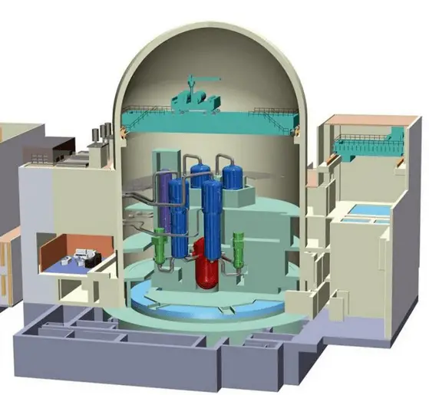
Nuclear Power Station Containment Building[].
The containment building is a gas-tight (shell) or other enclosure around a nuclear reactor and a primary circuit. The Containment is the most characteristic structure of a nuclear power plant. Practically all nuclear power plants built during the last few decades include a containment building.

The containment building should be designed to ensure or contribute to the achievement of the following safety functions:
- Confinement. Confinement of radioactive material in operational states and accident conditions.
- Protection. Protection of the power plant against external natural and human-induced events
- Shielding. Radiation shielding in operational states and accident conditions.

The containment building is primarily designed to prevent or mitigate the uncontrolled release of radioactive material to the environment in operational states and in accident conditions. Therefore it is considered to be the fourth and final barrier in the in-depth Defence strategy.

While the Containment plays a crucial role in Design Basis Accidents or Design Extension conditions, it is “only” designed to condense steam from primary coolant and contain it inside the building.

Side by Side Comparison for Containment Buildings for Windscale (UK), Chernobyl (USSR) and Fukushima (Japan)

Feature | Windscale | Chernobyl | Japan
Era | 1950 | 1970 | 1960-1970s
Reactor Type | Graphite – Air Cooled | Graphite – Water Cooled | Light Water - BWR
Full Containment | No | No | Yes (Mk1)
Pressure Rated | No | No | Yes (Primary Only)
Hydrogen Control | No | No | Limited
Explosion Resistance | No | No | Limited
Radioactive Release | Moderate | Extreme | Significant but limited
Table 2: Side By Side Comparison for Nuclear Incident Containment Buildings
See Glossary of terms for definitions of Features above.

Definition of Full Containment:
Full containment” means that a nuclear reactor is enclosed within a pressure-tight, sealed structure specifically engineered to prevent the release of radioactive material to the environment even during severe accidents.

Definition of Pressure Rated:
A pressure-rated containment is designed to withstand a defined maximum internal pressure resulting from accident conditions (e.g. steam release, gas generation) while maintaining structural integrity and leak tightness.

Definition of Hydrogen Control:
Hydrogen control is the set of engineered systems that prevent hydrogen gas from accumulating to explosive levels inside nuclear plant structures during accident conditions.

Definition of Explosion Resistance:
Explosion resistance is the ability of a structure to survive sudden shock and overpressure from explosions without catastrophic failure or loss of containment.

Definition of Radioactive Release:
Radioactive release is the escape of radioactive material beyond engineered barriers into the environment, whether controlled or uncontrolled.

Reactor Pressure Vessel:
Inside the Containment Building is where you will find the Reactor Pressure Vessel (RPV), think of this like a giant kettle where the nuclear fuel rods, coolant fluid and where the nuclear reactions take place. (Splitting of Atoms, the Nuclear Fission process, the boiling of water to help create steam to turn the turbines to create electricity. This is the beating heart of all nuclear power plants around the world.

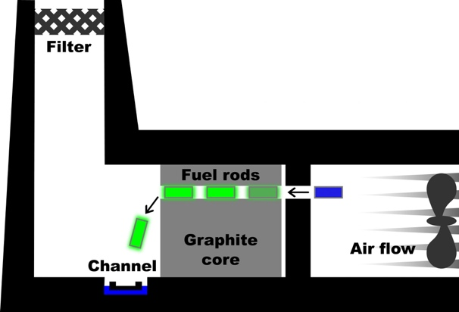 | 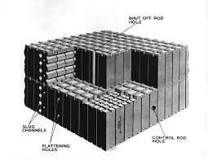
Windscale Pile 1 Reactor Core[] | Windscale Core[]

As shown above (Fig) the Windscale Core (Pile) consists of 2000te graphite Moderators/Reflector comprising of about 50,000 blocks of graphite blocks that are arranged in such a fashion of an interlocking structure. Measuring approximately 15m x 15m and 7.5m deep. The core contains 3444 horizontal fuel channels, 977 isotope channels. Each fuel channel contained a stringer of 21 solid uranium metal fuel rods clad in finned aluminium[]. As you can see from the image above there is no pressure vessel, this would not be able to contain any radionuclides in the event of an accident, and it proved in 1957 that it could not contain the radionuclides.

Chernobyl Reactor Core | Chernobyl Core

As shown above (Fig) the Chernobyl Reactor (RBMK1000) type Graphite Moderated Reactor

Fukushima Reactor Pressure Vessel | Fukushima RPV

Comparison of Reactors at Windscale, Chernobyl and Fukushima

Feature \ Location | Windscale (UK) | Chernobyl (USSR) | Fukushima (Japan)
Reactor Type | Air-cooled, graphite-moderated | Graphite-moderated, water-cooled | Light-water-moderated, water-cooled
Primary Purpose | Military plutonium production | Civil electricity generation | Civil electricity generation
Moderator | Graphite | Graphite | Light water
Coolant | Air | Light Water | Light water
Reactor Material | Graphite core blocks; aluminium fuel cladding; mild steel structures | Graphite moderator blocks; zirconium-niobium alloy pressure tubes; steel structures | Low-alloy steel reactor pressure vessel; zirconium alloy fuel cladding; stainless steel internals
Pressure Vessel | None (pile structure) | No single vessel (pressure tubes) | Single large steel RPV
Containment | None | Partial (no full containment) | Primary and secondary containment
Reactivity Coefficient^{[G]} | Poorly characterised | Positive void coefficient | Negative void coefficient
Passive Safety Features | Minimal | Limited | Moderate
Accident Trigger | Graphite Wigner energy release | Unstable low-power test + design flaws | Earthquake + tsunami
Radionuclide Release Mechanism | Open-core graphite fire | Core explosion + graphite fire | Venting + hydrogen explosions
Scale of Release | Limited but significant I-131 | Largest civil release | Large but lower than Chernobyl
Table 3: Comparison of Reactors

Fuel Cladding:

Fuel Matrix:

If any one of the 4 aspects above are breached this will result in release of radionuclides into the immediate area and up into the atmosphere.

Thermal Damage
Mechanical Failure or Explosion
Fire
Chemical Processes
Pressure Relief / Venting

The incident at Chernobyl on the 26th April 1986 resulted in the reactor exploding and releasing an enormous amount of radionuclides (Including reactor fuel) and building debris to the immediate surrounding area of the plant and adjacent buildings, the majority of the radionuclide release occurred over the prevailing 10 days that the reactor core was on fire. The hot air and fumes from the burning core forced radionuclides up into the atmosphere.

What type of Radionuclides were released at Chernobyl?
The incident at Chernobyl in 1986 released a wide variety of radionuclides including everything from short-lived isotopes (Iodine) to long-lived isotopes such as caesium and strontium and even plutonium,

2.1.2.2: How radionuclides disperse in the environment
Radionuclide Dispersal methods

2.1.2.2.a: Windscale (UK) Dispersal
According to Garland (2007), atmospheric dispersal of radionuclides from the Windscale Pile commenced between 15:00 and 16:00 on 10 October 1957 and persisted until approximately midday on 11 October 1957. The emissions were dominated by iodine-131 (¹³¹I), caesium-137 (¹³⁷Cs), and polonium-210 (²¹⁰Po), which constituted the primary contributors to radiological release[].

Atmospheric Dispersal
Hydrological Dispersal
Soil and Sediment Transport
Resuspension

2.1.2.2.e: Chernobyl (USSR) Radionuclide Dispersal to the United Kingdom
Following the explosion and catastrophic destruction of Reactor No. 4 at the Chernobyl Nuclear Power Plant, radioactive fuel fragments, aerosols, and debris were released directly from the reactor core. Atmospheric emissions continued for several days until the core fires were fully suppressed. Meteorological conditions resulted in the transport of radionuclides predominantly in a north-westerly direction, leading to the initial contamination of the nearby city of Pripyat, Ukraine.
Through comparative analysis and integration of datasets obtained from the UK Meteorological Office (Met Office) and established Chernobyl cloud deposition records, spatial patterns of radionuclide deposition across the United Kingdom were reconstructed. The resulting deposition maps were used to guide the strategic placement of the wireless sensor network during the field research phase of this study.

Over several days from the 26th April 1986 winds carried radioactive particles across North Europe up into Scandinavia and Sweden and also across western Europe, on the 1st May 1986 at around 22:30 IRSN Chernobyl Cloud data[] show the radioactive cloud broke the boarders of the United Kingdom around the South East coast (see Image):

Data from the UK Meteorological Office show that no rainfall was recorded during the period of interest. This is important because precipitation is a primary mechanism for wet deposition of airborne radionuclides. Rainfall would have accelerated the removal of radionuclides from the atmospheric plume, resulting in enhanced deposition onto terrestrial surfaces and subsequent contamination of land, grazing animals, and the human food chain.

However, over the next few days some areas of the UK were not so lucky and with the cloud and rainfall, areas became contaminated, over the next few pages I will chart and explain these depositions.
Met Office | IRSN
Weather and Cloud Data 21:00 on 1st May – 09:00 on 2nd May 1986
As previously stated on the 1st May 1986 at around 22:30 - 23:00 winds from the southeast brought the radioactive cloud from Chernobyl and broke the southeastern border of the United Kingdom (See Image above).

Met Office | IRSN
Weather & Cloud Data 09:00 on 2nd May – 21:00 on 2nd May 1986
Winds continued to blow west and north westerly covering the south and south west of England

Met Office | IRSN
Weather & Cloud Date 21:00 2nd May – 09:00 3rd May 1986

Met Office | IRSN
Weather & Cloud Data 09:00 3rd May – 21:00 3rd May 1986

Met Office | IRSN
Weather & Cloud Data 21:00 3rd May – 09:00 4th May 1986

Met Office | IRSN
Weather & Cloud Data 09:00 4th May – 21:00 4th May 1986

Met Office | IRSN
Weather & Cloud Data 21:00 4th May – 09:00 5th May 1986

Met Office | IRSN
Weather & Cloud Data 09:00 5th May – 21:00 5th May 1986

Met Office | IRSN
Weather & Cloud Data 21:00 5th May – 09:00 6th May 1986

Met Office | IRSN
Weather & Cloud Data 09:00 6th May – 21:00 6th May 1986

Met Office | IRSN
Weather & Cloud Data 21:00 6th May – 09:00 7th May 1986

Chernobyl related Radionuclide Depositions over Dartmoor and the South West of England

A Research Paper will be produced based on this information
Investigating Radiological Contamination of the UK Environment (Dartmoor National Park) four decades after the Chernobyl Incident using IoT Networks and Sensing Technology (using GammaNet).

Chernobyl related Radionuclide Depositions over the North West Wales
A Research Paper will be produced based on this information

Chernobyl related Radionuclide Depositions over Cumbria
A Research Paper will be produced based on this information

Chernobyl related Radionuclide Depositions over the Isle of Man
A Research Paper will be produced based on this information

Chernobyl related Radionuclide Depositions over North West Scotland.
A Research Paper will be produced based on this information

2.1.2.c: How radionuclides transform
Once released, they may undergo:
- Radioactive decay
- Chemical reactions
- Particle agglomeration or fragmentation
- Sorption to soil or sediments

2.1.2.d: How radionuclides interact with living systems
This section is important to the reader to help understand how and why radionuclides can be dangerous and how they affect the living system(s) from plants to animals how radionuclides affect the food chain and ultimately how and why they are dangerous to the human body.

This includes:
plant uptake,
bioaccumulation in animals,
food-chain transport,
human exposure pathways (inhalation, ingestion, immersion).

2.1.2.e: Modelling and prediction
Radionuclide dispersal theory supports modelling tools used in nuclear safety and emergency response, such as:
- Gaussian plume models (GPM),
- Lagrangian particle models (LPM),
- NAME – Lagrangian Atmospherics Dispersal Model (UK Met Office).
- Hydrodynamic transport simulations.
These models predict where radioactive contamination will go, how far, how fast, and what concentrations may occur.

2.1.3: Radiation Monitoring System Principles

2.1.4: IoT and Wireless Sensor Network (WSN) Theory

2.1.5: Frameworks used in IoT Radiological Monitoring

2.1.6: Conclusion of 2.1
2.2 Related Work – Previous research in your domain.
In this section I shall move my focus more towards my research in relation to the incident at Chernobyl and the United Kingdom.

2.2.1: Academic and Historical Work on the Chernobyl Incident

2.2.2: Studies of Radionuclide Dispersal across Europe / UK

2.2.3: Past Monitoring Systems

2.2.4: IoT and Sensor Network Research

2.2.5: IoT Based Radiological Monitoring Systems

2.2.6: Conclusion of 2.1
2.3 Gap Analysis – Identify shortcomings in prior work.

2.3.1: Gaps in Chernobyl Focused Research

2.3.2: Gaps in Radionuclide Dispersals understanding for the United Kingdom

2.3.3: Gaps in Existing Monitoring Systems

2.3.4: Gaps in IoT and WSN Research

2.3.5: Combined Multidisciplinary Gap

2.3.6: Conclusion of 2.3
2.4 Summary – How your research addresses these gaps.

2.4.1: Summarise the Theoretical Foundations.

2.4.2: Summarise what existing literature has done.

2.4.3: Restate the Gaps

2.4.4: Show how your research addresses the gaps

